UNITED STATES

SECURITIES AND EXCHANGE COMMISSION

Washington, D.C. 20549

 |  |  | FORM 8-K
 |  |  | CURRENT REPORT
 |  |  | PURSUANT TO SECTION 13 OR 15(d) OF THE
 |  |  | SECURITIES EXCHANGE ACT OF 1934
 | Date of Report (Date of earliest event reported): December 13, 2023
 |  |  | Presto Automation Inc.
 |  |  | (Exact name of registrant as specified in its charter)
Delaware | 001-39830 |  |  |  |  | 84-2968594
(State or other jurisdiction |  |  | (Commission File Number) |  |  | (IRS Employer
of incorporation) |  |  |  |  |  | Identification No.)
 |  |  | 985 Industrial Road
 |  |  | San Carlos, CA 94070
 |  | (Address of principal executive offices, including zip code)
 | Registrant’s telephone number, including area code: (650) 817-9012
 |  |  | Not Applicable
 |  | (Former name or former address, if changed since last report)

Check the appropriate box below if the Form 8-K filing is intended to simultaneously satisfy the filing obligation of the registrant under any of the following provisions:

- Written communications pursuant to Rule 425 under the Securities Act (17 CFR 230.425)

- Soliciting material pursuant to Rule 14a-12 under the Exchange Act (17 CFR 240.14a-12)

- Pre-commencement communications pursuant to Rule 14d-2(b) under the Exchange Act (17 CFR 240.14d-2(b))

- Pre-commencement communications pursuant to Rule 13e-4(c) under the Exchange Act (17 CFR 240.13e-4(c)) Securities registered pursuant to Section 12(b) of the Act:

 |  |  |  | Name of each exchange on which
Title of each class |  | Trading Symbol(s) |  | registered
Common stock, par value $0.0001 per share |  | PRST |  | The Nasdaq Stock Market LLC
Warrants, each whole warrant exercisable for one share of |  | PRSTW |  | The Nasdaq Stock Market LLC
common stock

Indicate by check mark whether the registrant is an emerging growth company as defined in Rule 405 of the Securities Act of 1933 (§230.405 of this chapter) or Rule 12b-2 of the Securities Exchange Act of 1934 (§240.12b-2 of this chapter).

Emerging growth company ☒

If an emerging growth company, indicate by check mark if the registrant has elected not to use the extended transition period for complying with any new or revised financial accounting standards provided pursuant to Section 13(a) of the Exchange Act. ☐

Item 5.02 Departure of Directors or Certain Officers; Election of Directors; Appointment of Certain Officers; Compensatory Arrangements of Certain Officers

On December 13, 2023, Nathan Cook submitted his resignation as Interim Chief Financial Officer of Presto Automation Inc. Company (“Presto” or the “Company”), effective immediately. Mr. Cook was engaged as Interim Chief Financial Officer pursuant to an agreement with Teneo Capital LLC (“Teneo”) that required the Company to pay a monthly fee of $90,000, a copy of which was filed as Exhibit 10.12 to the Current Report on Form 8-K filed with the Securities and Exchange Commission on October 11, 2023. The agreement with Teneo terminated upon the Company’s notice to Teneo on the date hereof.

On December 14, 2023, the Board of Directors (the “Board”) of Presto appointed Stanley Mbugua to serve as Interim Chief Financial Officer, effective immediately.

Mr. Mbugua has served as Chief Accounting Officer of the Company since March 2023, a role in which he will remain while serving as Interim Chief Financial Officer, and as the Interim Chief Financial Officer from August 2023 to October 2023. From September 2021 to March 2023, Mr. Mbugua served as Chief Accounting Officer at Skillz Inc., a mobile eSports platform, a position he held since 2021. Mr. Mbugua served as Group Vice President and Chief Accounting Officer of Rimini Street, a software company delivering third-party enterprise software support for Oracle, SAP, JD Edwards, PeopleSoft, Siebel, and other applications, from 2017 to 2021. From 2015 to 2017, Mr. Mbugua served as Senior Director and Corporate Controller at Lattice Semiconductor Corp., a manufacturer of high-performance programmable logic devices. Mr. Mbugua is a Certified Public Accountant and has a Bachelor’s degree from the University of Nairobi.

The Company is in the process of determining potential changes to the compensation arrangements for Mr. Mbugua.

There are no other arrangements or understandings pursuant to Mr. Mbugua’s appointment as Interim Chief Financial Officer. There are no family relationships among any of the Company’s executive officers, members of the Board and Mr. Mbugua, and there are no transactions with Mr. Mbugua that require disclosure pursuant to Item 404(a) of Regulation S-K.

Item 7.01 Regulation FD Disclosure

Investor Presentation

On December 14, 2023, the Company posted an updated investor presentation to its website. A copy of the investor presentation is attached as Exhibit 99.1 to this Current Report on Form 8-K.

The Company notes as follows:

- For restaurant locations that use the Company’s AI technology (e.g., locations other than Checkers which is powered by Hi Auto’s solution), the Company tracks the Non-Intervention Rate (NIR). NIR is a measure of how frequently the Company’s system is able to independently process a drive-thru customer’s order without a member of the restaurant’s staff needing to take over that order. NIR does not relate to the Company’s use of human agents (referred to “humans-in-the-loop” or HITL) in connection with the Company’s AI technology. NIR across all restaurants enabled by Company’s technology is 85% on average, with certain restaurant locations at 95% or higher.

- At select locations where the Company is piloting the most advanced version of its AI technology, approximately 30% of orders taken at those locations do not require human agents to enter the orders. With this version of the AI engine, although the AI is able to complete the order without a human agent intervention, human supervision ensures that the AI is accurately entering the order and is immediately ready to review, validate and correct orders if necessary. The Company is rolling out this enhanced AI capability to all restaurants enabled by the Company’s AI technology and targets enabling more than 80% of these stores by March 31, 2024. Pending the completion of that roll out, locations that use the Company’s AI technology currently use human agent intervention, including entering the order, in all instances.

1

Press Release

On December 14, 2023, the Company issued a press release titled “Presto’s VoiceTM AI Solution Projected to Capitalize on Strong Momentum as Company Releases 2024 and 2025 Projected Annualized Run Rate Targets.” A copy of the press release is attached as Exhibit 99.2 to this Current Report on Form 8-K.

The information in Item 7.01 of this Current Report on Form 8-K, including Exhibits 99.1 and 99.2 attached hereto, is being furnished and shall not be deemed “filed” for the purposes of Section 18 of the Securities Exchange Act of 1934, as amended (the “Exchange Act”), or otherwise subject to the liabilities of that Section, nor shall it be deemed subject to the requirements of amended Item 10 of Regulation S-K, nor shall it be deemed incorporated by reference into any filing of the Company under the Securities Act of 1933, as amended, or the Exchange Act, whether made before or after the date hereof, regardless of any general incorporation language in such filing. The furnishing of this information hereby shall not be deemed an admission as to the materiality of any such information.

Item 9.01 Financial Statements and Exhibits.

(d) Exhibits

Exhibit No. Description

99.1

99.2

104

Investor Presentation

Press Release titled “Presto’s VoiceTM AI Solution Projected to Capitalize on Strong Momentum as Company Releases 2024 and 2025 Projected Annualized Run Rate Targets”
Cover Page Interactive Data File (embedded within Inline XBRL document).

2

SIGNATURE

Pursuant to the requirements of the Securities Exchange Act of 1934, the registrant has duly caused this report to be signed on its behalf by the undersigned hereunto duly authorized.

PRESTO AUTOMATION INC.

By: /s/ Susan Shinoff

Name: Susan Shinoff

Title: General Counsel and Corporate Secretary

Dated: December 14, 2023

3

Exhibit 99.1
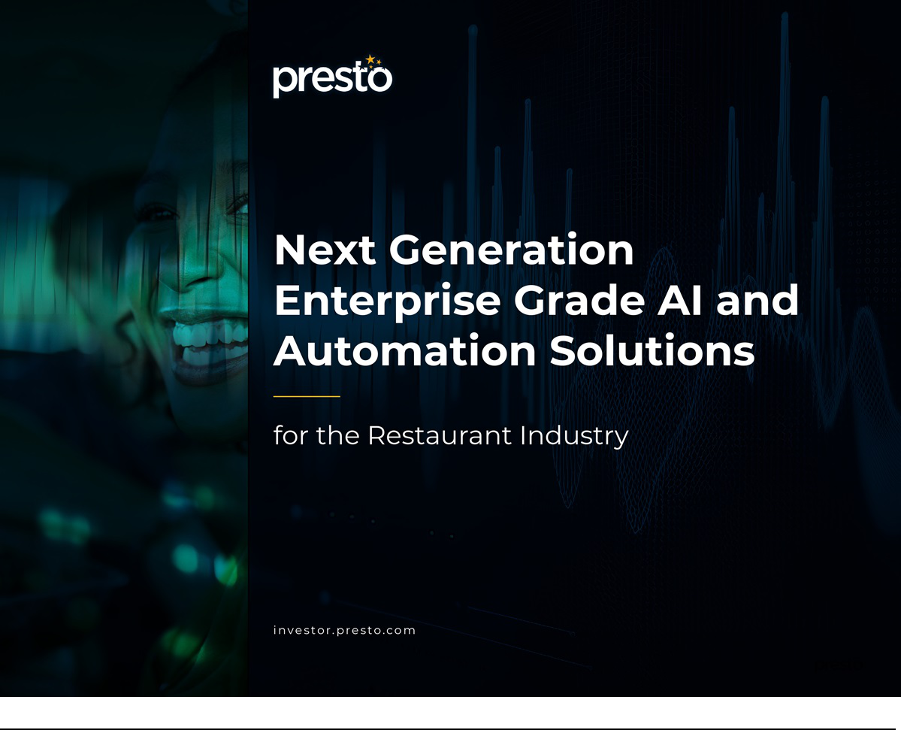

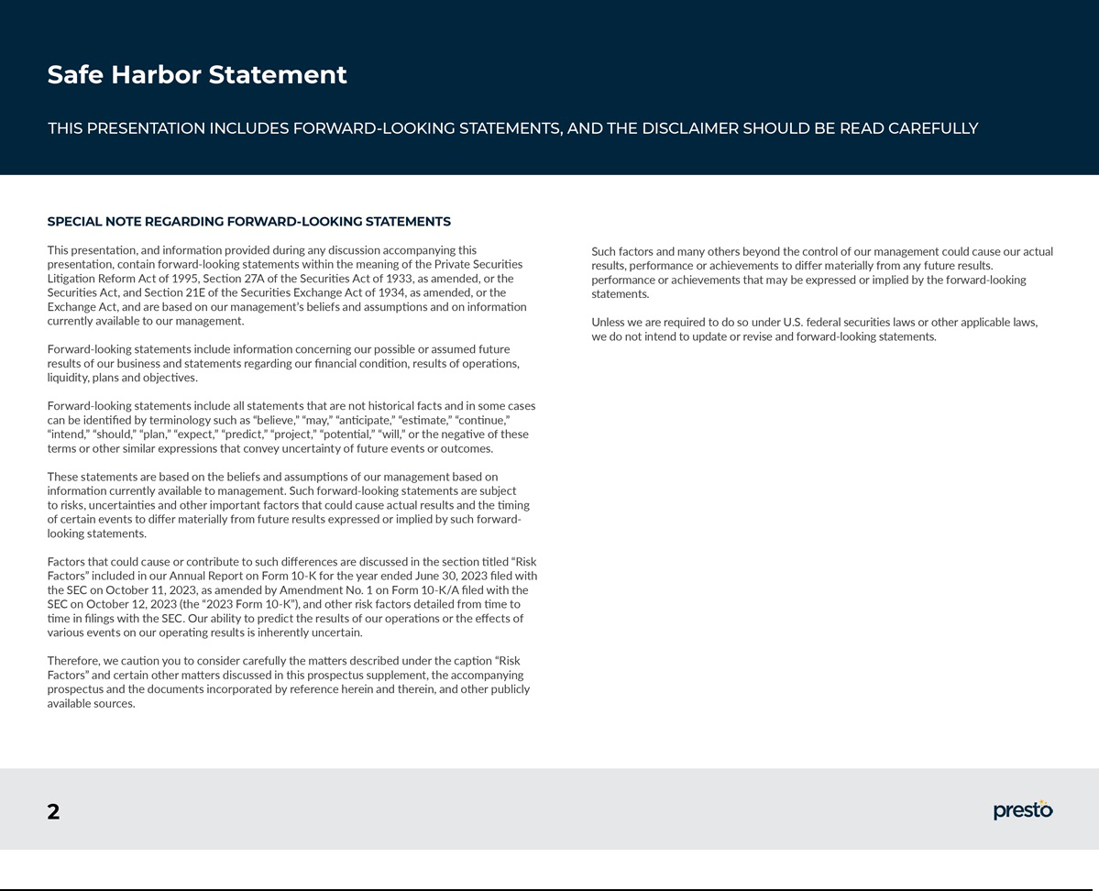

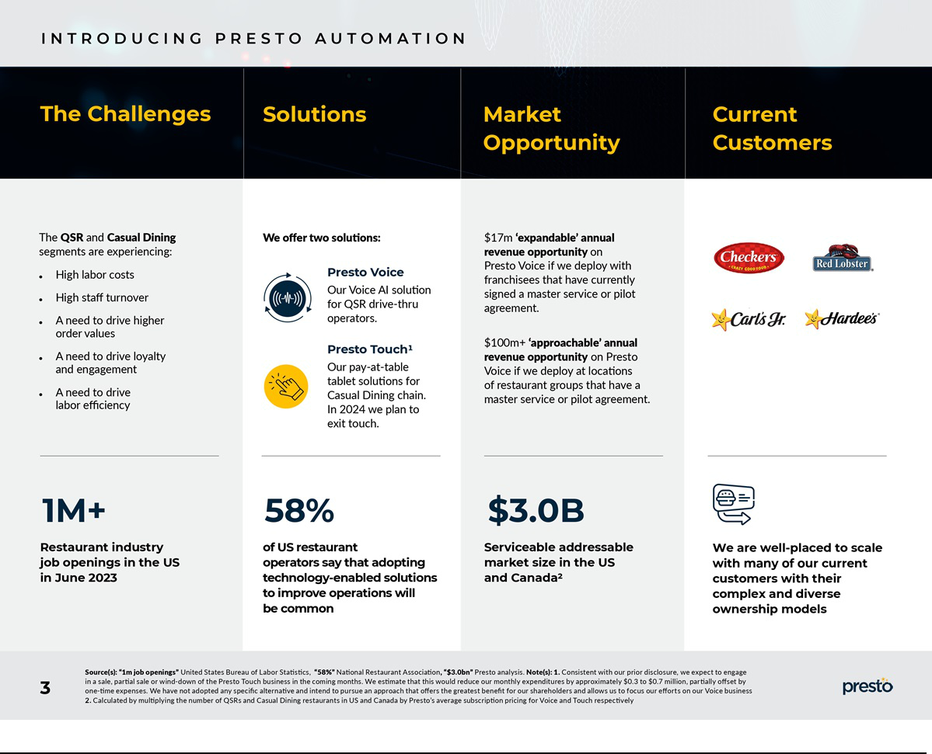

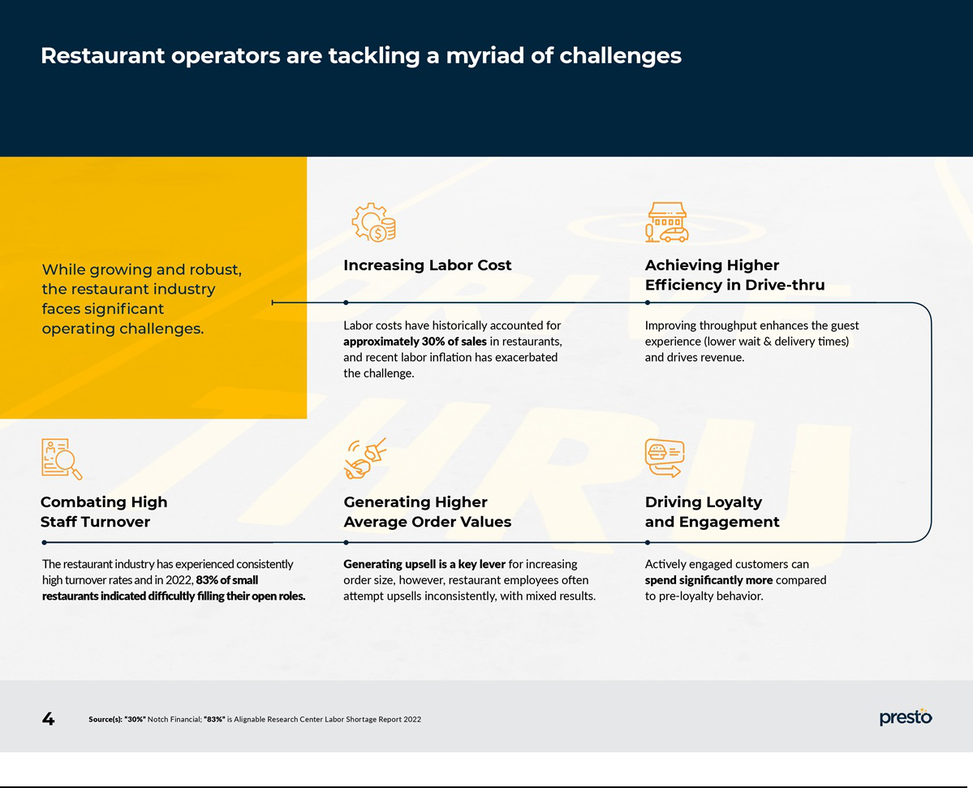

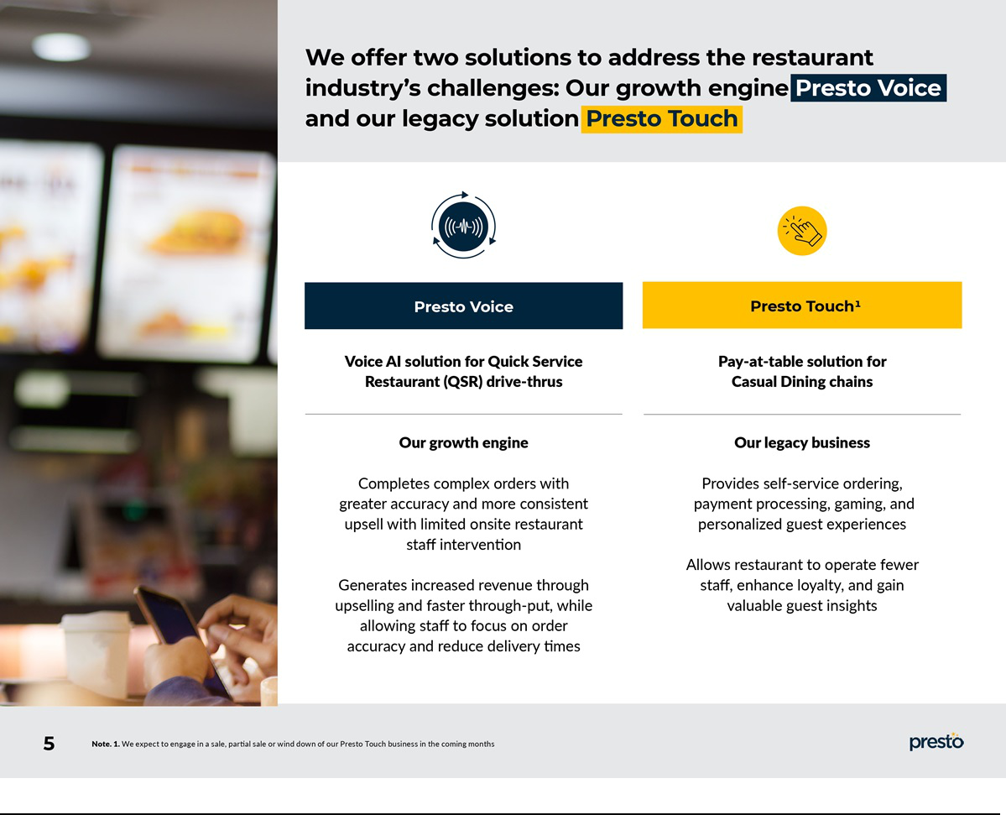

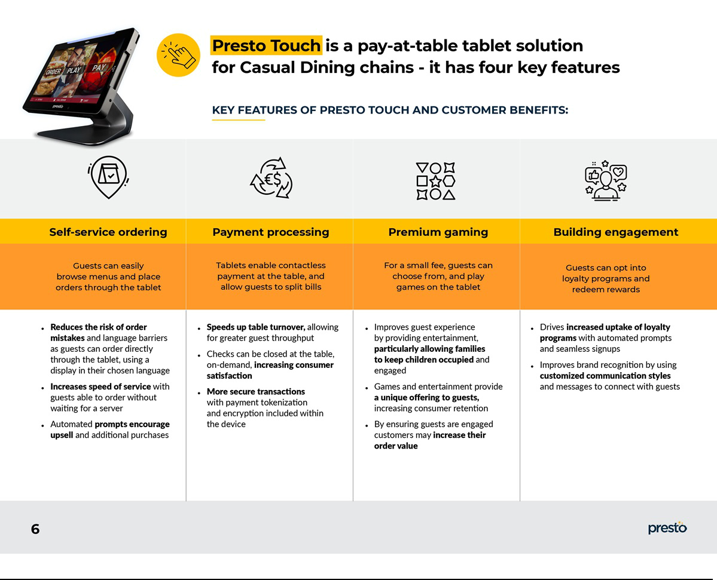

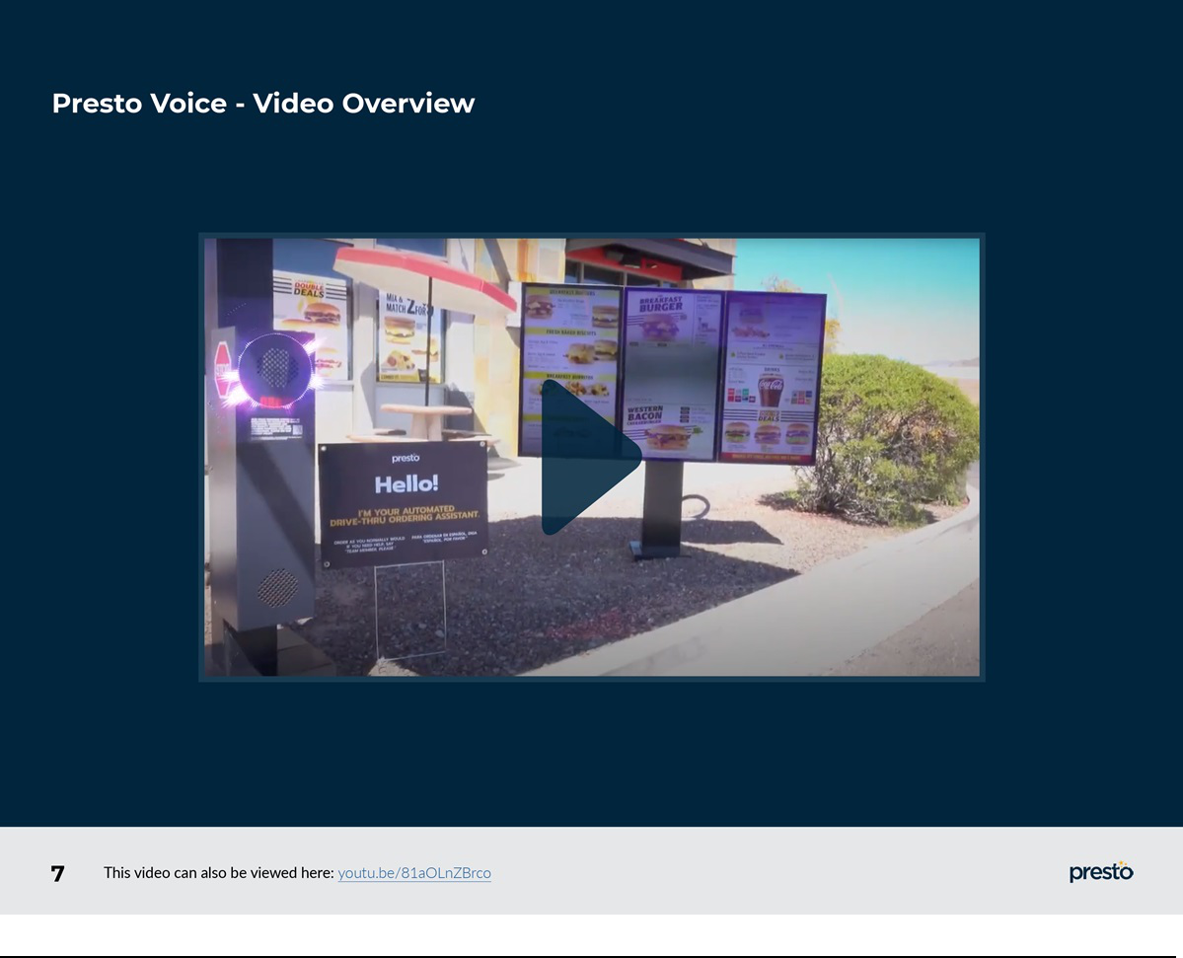

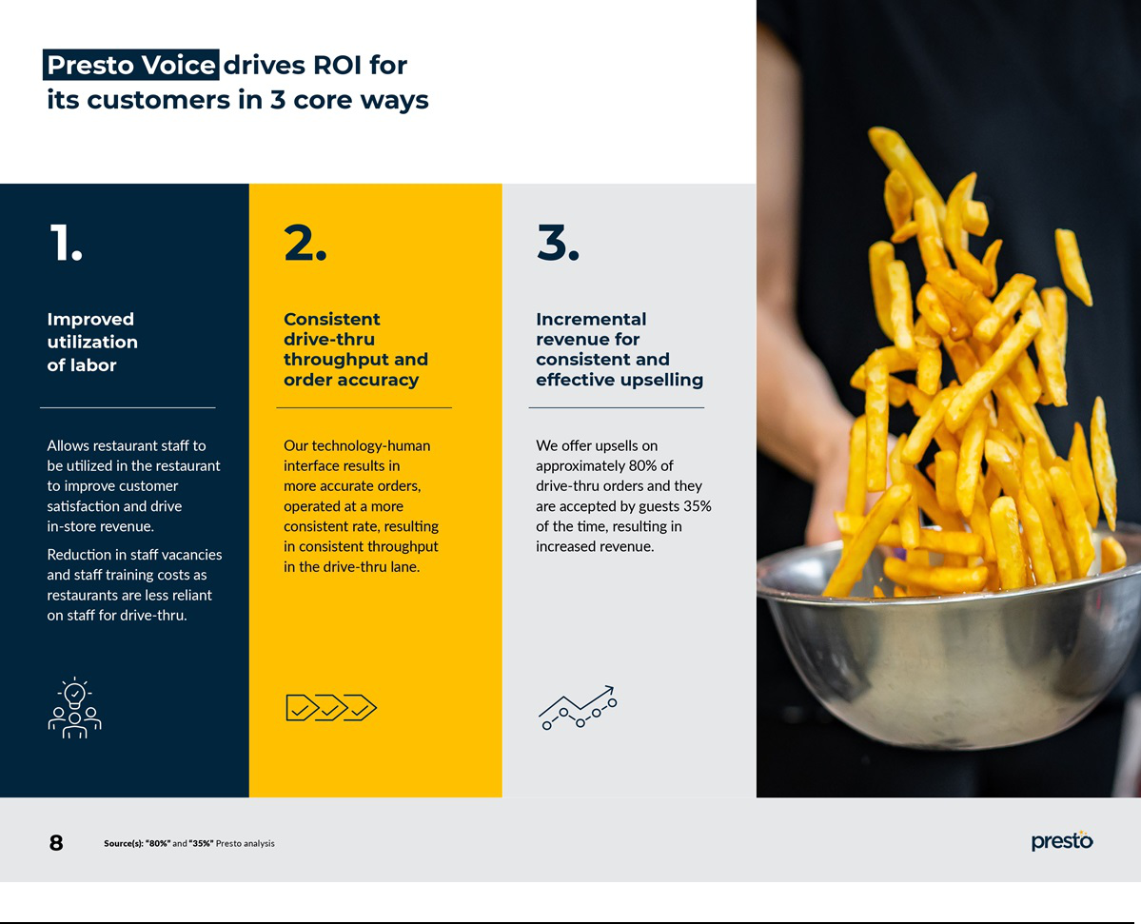

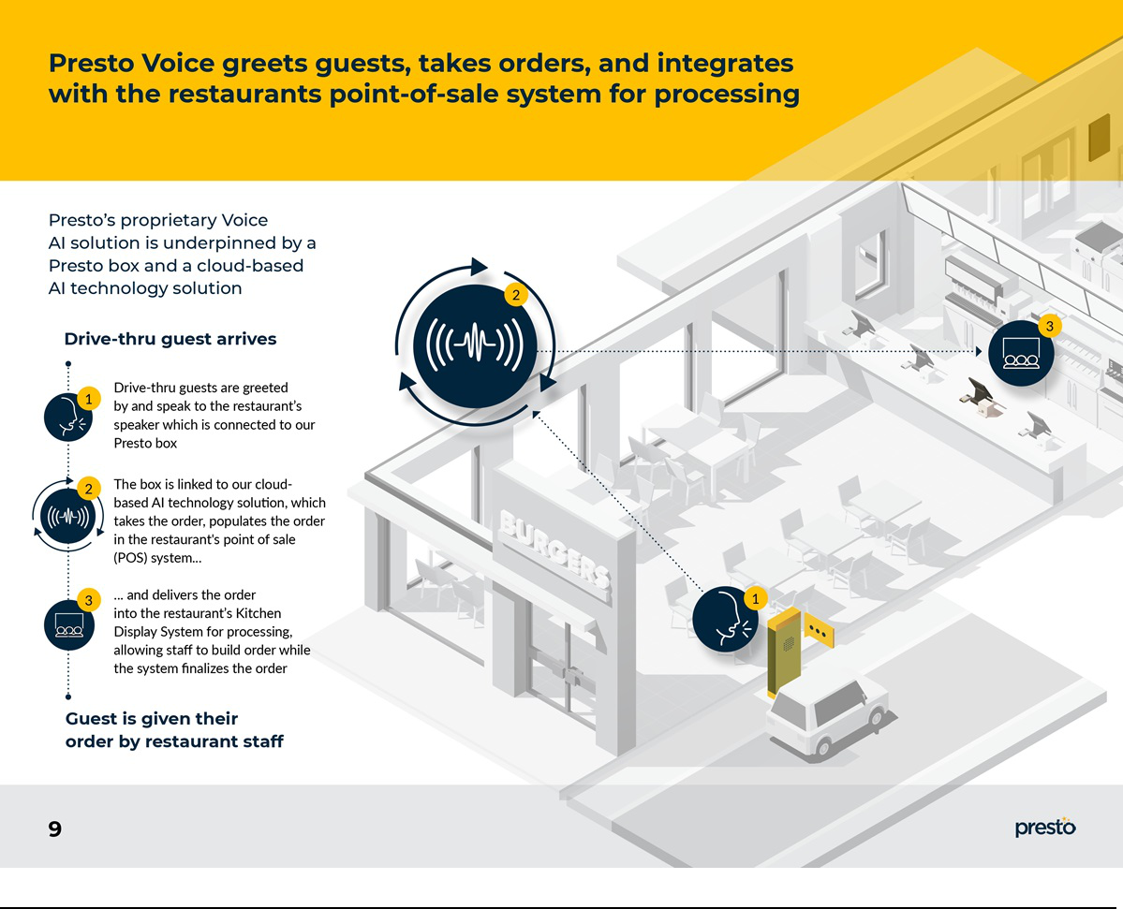

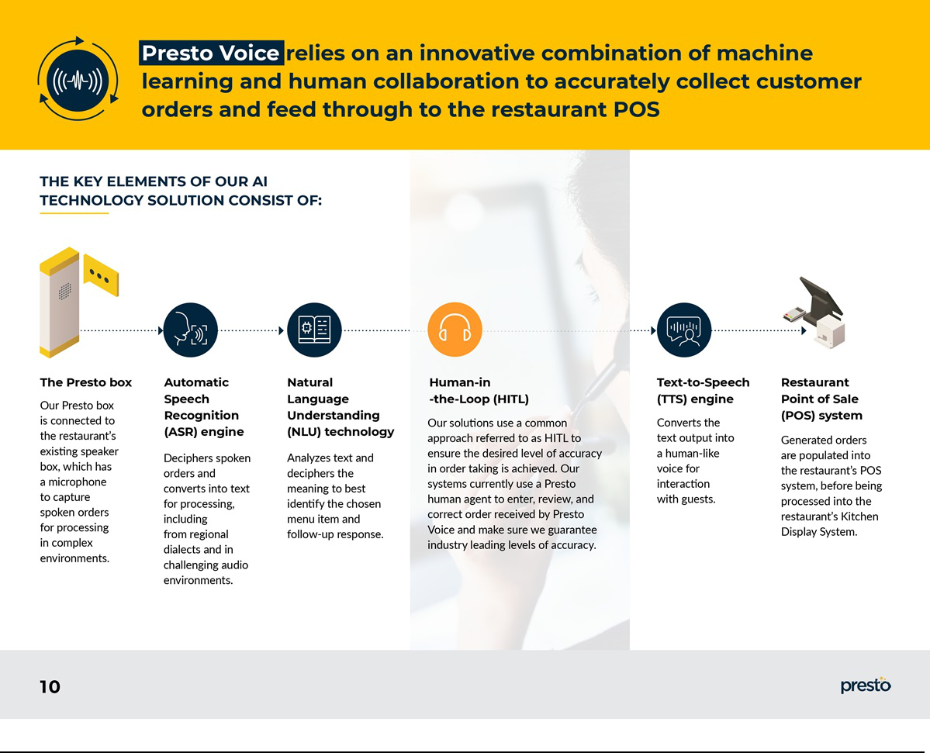

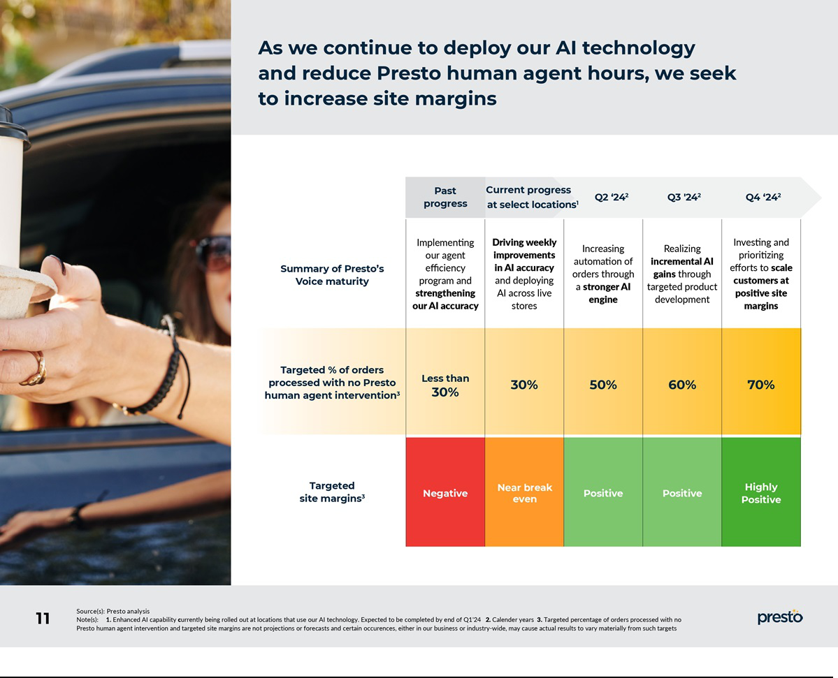

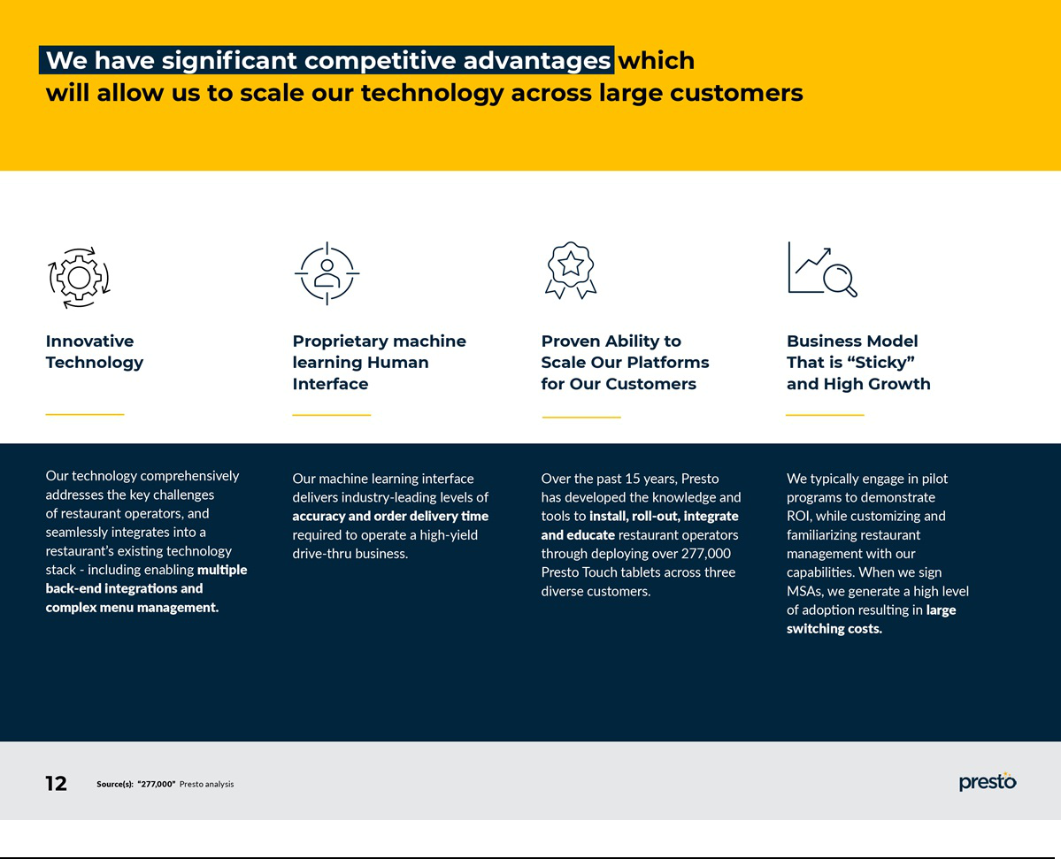

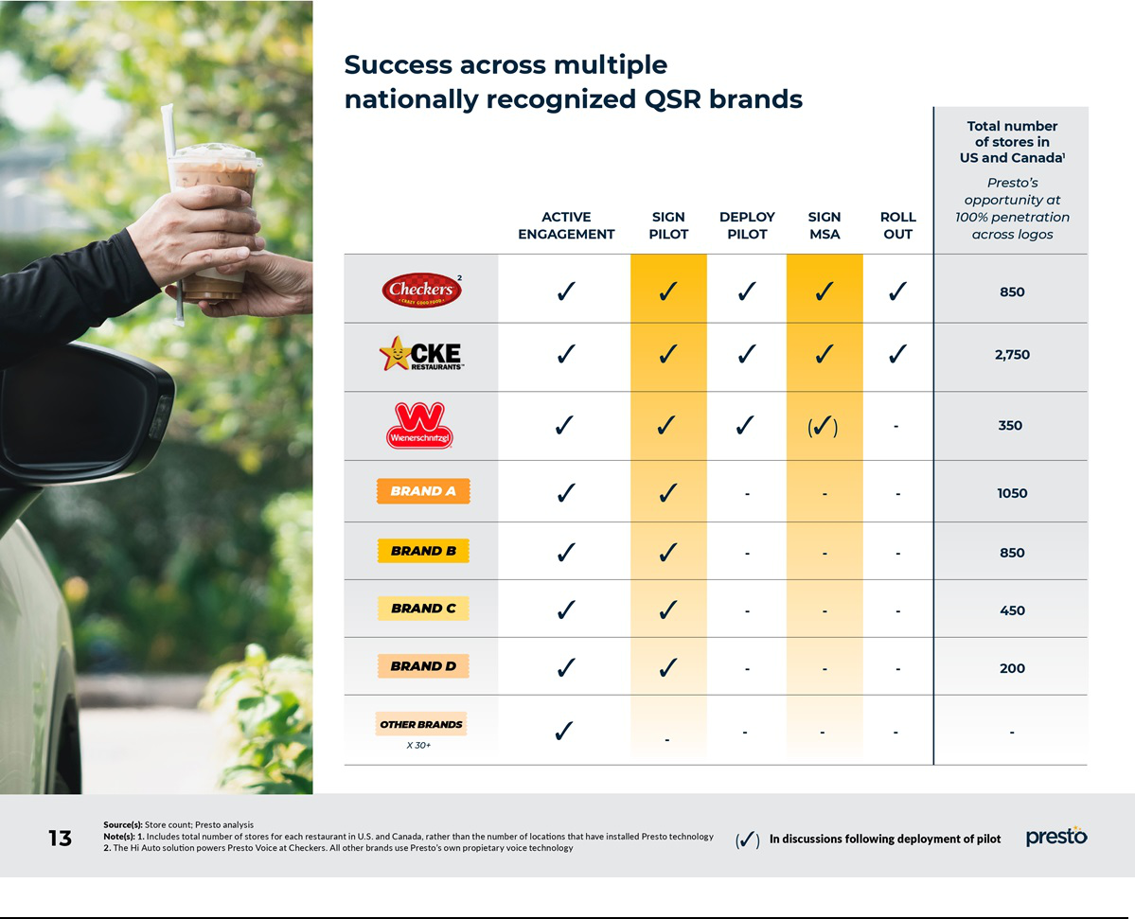

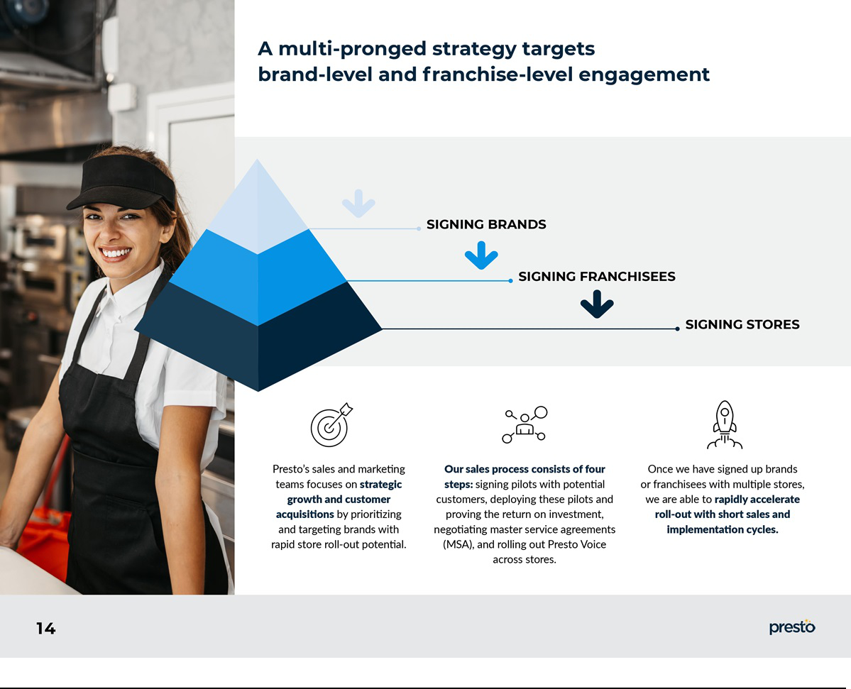

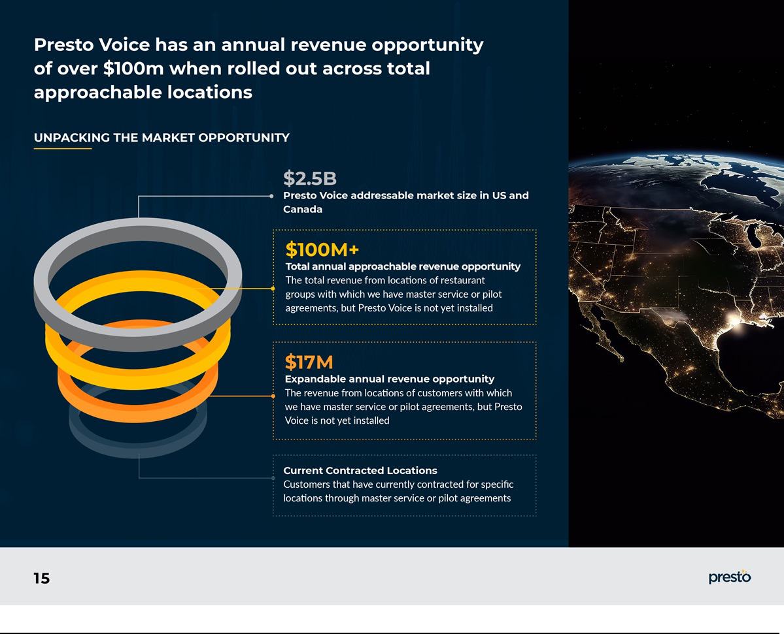

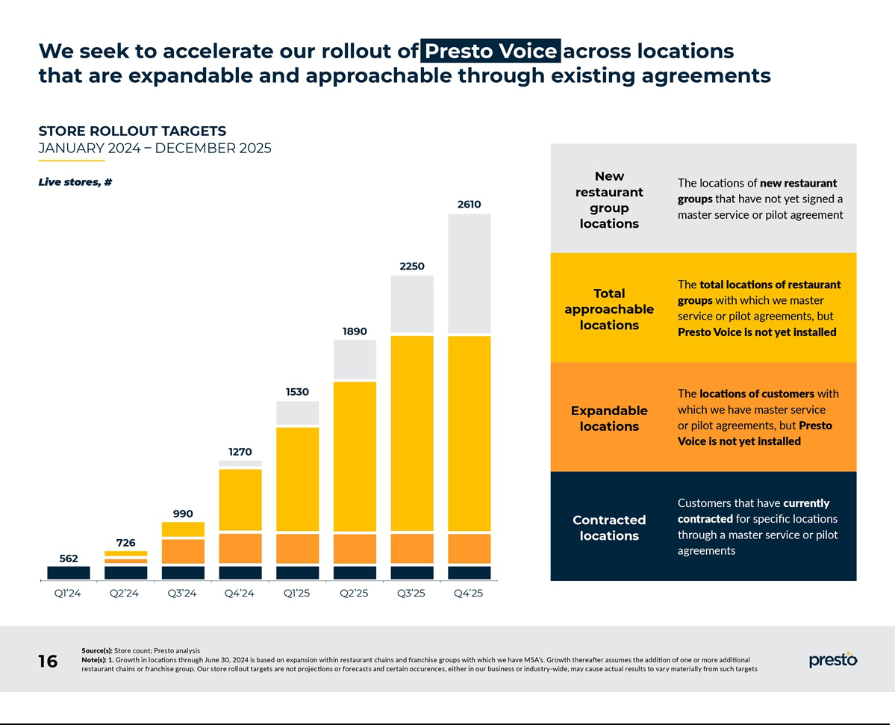

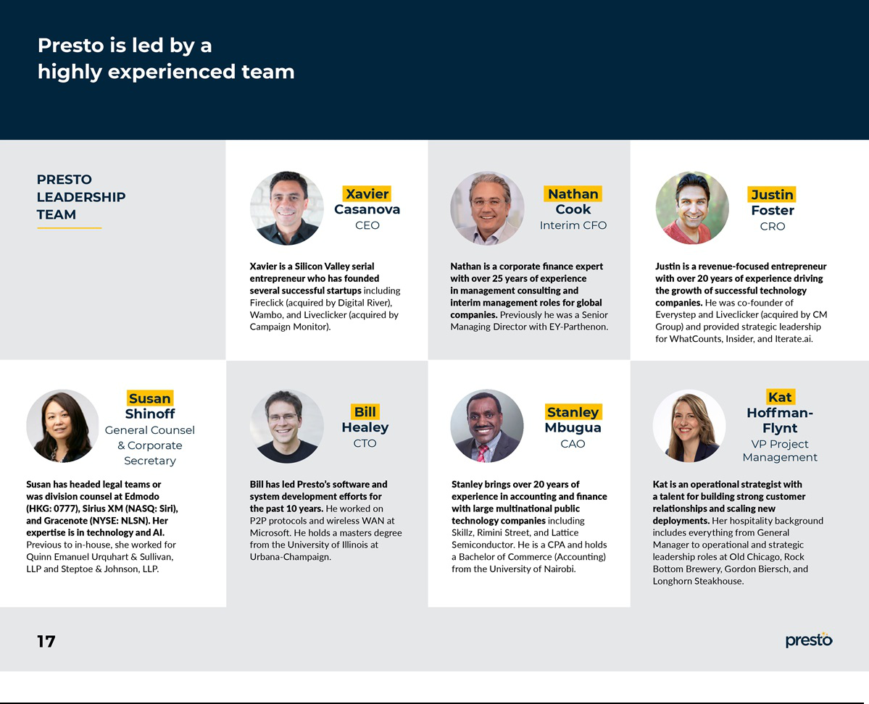

Exhibit 99.2

Presto’s VoiceTM AI Solution Projected to Capitalize on Strong Momentum as Company Releases 2024 Projected Annualized Run Rate

Presto Automation Inc. (NASDAQ: PRST), one of the largest drive-thru automation technology providers in the hospitality industry, today provided additional information to investors about its projected financial results for calendar year 2024.

As a result of the strong momentum being experienced in its Voice AI solution, Presto is estimating its projected annualized run rate (PARR) to be $17.6M at the end of calendar year 2024, which is directly correlated to the store count projection the company has already released (1270 stores by the end of 2024). We define PARR as the annualized revenue of contracts for our Presto Voice AI solution that are projected to be in effect at the end of the relevant period.

“These projections should convey the market-leading momentum we are seeing in our Presto Voice business as our store count continues to go up and we convert more of our signed and immediate revenue opportunity into live revenue. We expect to be a business of real scale over the course of 2024 and we expect to remain the market leader,” said Krishna Gupta, Chairman of Presto.

As of the date hereof, PARR reflects 404 currently contracted locations with 866 additional projected contracted locations by the end of 2024. As a result, a significant portion of the PARR is based on our expectation that we will roll out additional locations. Our pricing assumes the continuation of our pricing arrangements with Checkers and pricing assumptions which reflect our experience with recent additions of new locations.

We believe that our PARR is a useful measure of our overall expected volume at a particular point in time and of changes in the volume of business over time because it allows investors to understand how we expect our business to scale and eliminates the time impact associated with the signing of new contracts during a quarterly or annual period.

Our Voice contracts are generally for 12-month terms. Our two most significant Voice contracts can be terminated upon 2 months’ notice or on a location-by-location basis, respectively, if minimum service levels are not maintained. All of our contracts have “evergreen” provisions that extend their term automatically unless the customer provides notification of non-renewal. Therefore, unless a notice of non-renewal has been received, our PARR calculation assumes that each contract in place currently will continue through the end of the relevant reporting period.

Forward-Looking Statements

This press release contains forward-looking statements within the meaning of Section 27A of the Securities Act of 1933, as amended (the “Securities Act”), and Section 21E of the Securities Exchange Act of 1934, as amended (the “Exchange Act”). Statements that refer to projections, forecasts or other characterizations of future events or circumstances, including any underlying assumptions, are forward-looking statements. Forward-looking statements are typically identified by words such as “plan,” “believe,” “expect,” “anticipate,” “intend,” “outlook,” “estimate,” “forecast,” “project,” “continue,” “could,” “may,” “might,” “possible,” “potential,” “predict,” “should,” “would” and other similar words and expressions, but the absence of these words does not mean that a statement is not forward-looking.

The forward-looking statements are based on management’s current expectations and assumptions about future events and are based on currently available information as to the outcome and timing of future events. The forward-looking statements speak only as of the date of this press release or as of the date they are made. Except as otherwise required by applicable law, Presto disclaims any duty to update any forward-looking statements, all of which are expressly qualified by the statements in this section, to reflect events or circumstances after the date of this press release. Presto cautions you that these forward-looking statements are subject to numerous risks and uncertainties, most of which are difficult to predict and many of which are beyond the control of Presto. In addition, Presto cautions you that the forward-looking statements contained in this press release are subject to the following risks and uncertainties: our ability to manage our growth effectively, to sustain our recent revenue growth or attract new customers; the limited operating history with our new Voice products in a new and developing market; our ability to roll out new locations within a specified amount of time; our ability to achieve revenue growth while our expenses increase; continued adverse impacts from COVID-19 (including as a result of global supply chain shortages); the loss of any of our three largest customers or a reduction in their business with us; our ability to improve and enhance the functionality, performance, reliability, design, security, or scalability of our platform to respond to customers’ evolving needs; our ability to protect the security of our customers’ information; changing privacy laws, regulations and standards, and our ability to comply with contractual obligations and laws related to data privacy and security; unfavorable conditions in the restaurant industry or the global economy, including with respect to food, labor, and occupancy costs; the availability of capital or financing on acceptable terms, if at all; financial covenants and other restrictions on our actions contained in our financing agreements that may limit our operational flexibility; the length and unpredictability of our sales cycles and the amount of investments required in sales efforts; material weaknesses in our internal control over financial reporting and, our ability to remediate these deficiencies; our ability to continue as a going concern; our ability to receive additional financing in a timely manner; shortages, price increases, changes, delays or discontinuations of hardware; our ability to maintain relationships with our payment processors; our relies on computer hardware, licensed software and services rendered by third parties; U.S. laws and regulations (including with respect to payment transaction processing), many of which are unsettled and still developing, and our or our customers’ ability to comply with such laws and regulations; significant changes in U.S. and international trade policies that restrict imports or increase tariffs; any requirements to collect additional sales taxes or be subject to other tax liabilities that may increase the costs to our customers; our ability to adequately protect our intellectual property rights; claims by third parties of intellectual property infringement; our use of open-source software in our platform; and other economic, business, competitive and/or regulatory factors affecting Presto’s business generally as set forth in our filings with the Securities and Exchange Commission.

