Filed by Ventoux CCM Acquisition Corp.

pursuant to Rule 425 under the Securities Act of 1933

and deemed filed pursuant to Rule 14a-12

under the Securities Exchange Act of 1934

Subject Company: E La Carte, Inc. (dba Presto)

Commission File No.: 001-39830
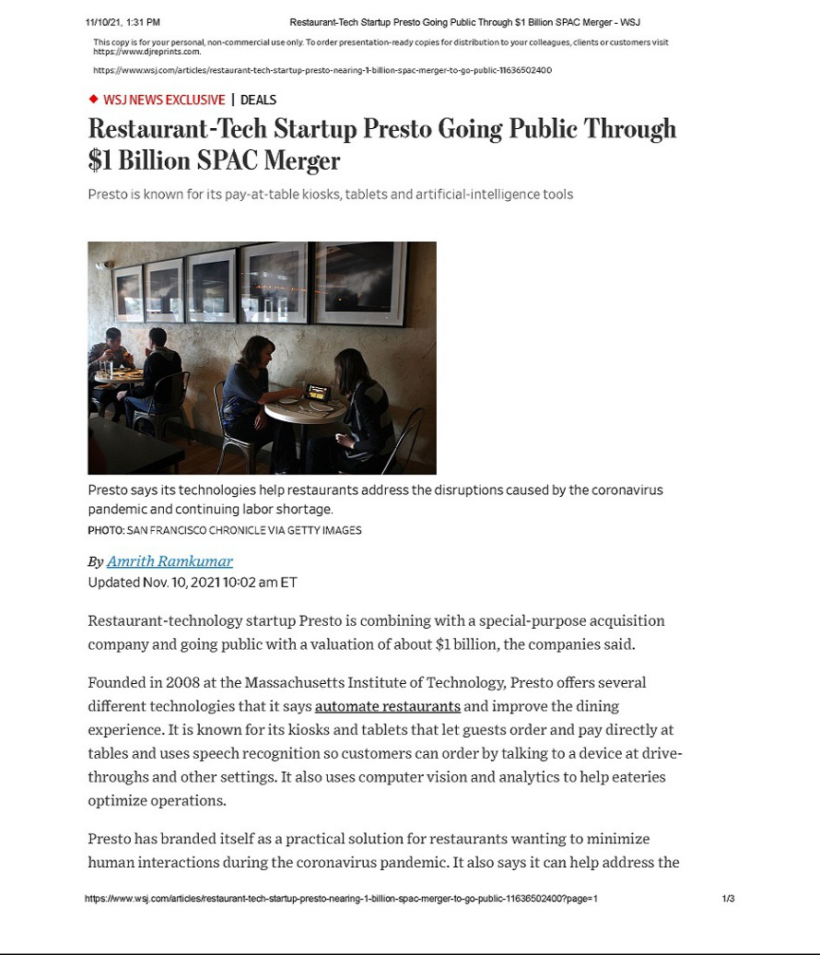

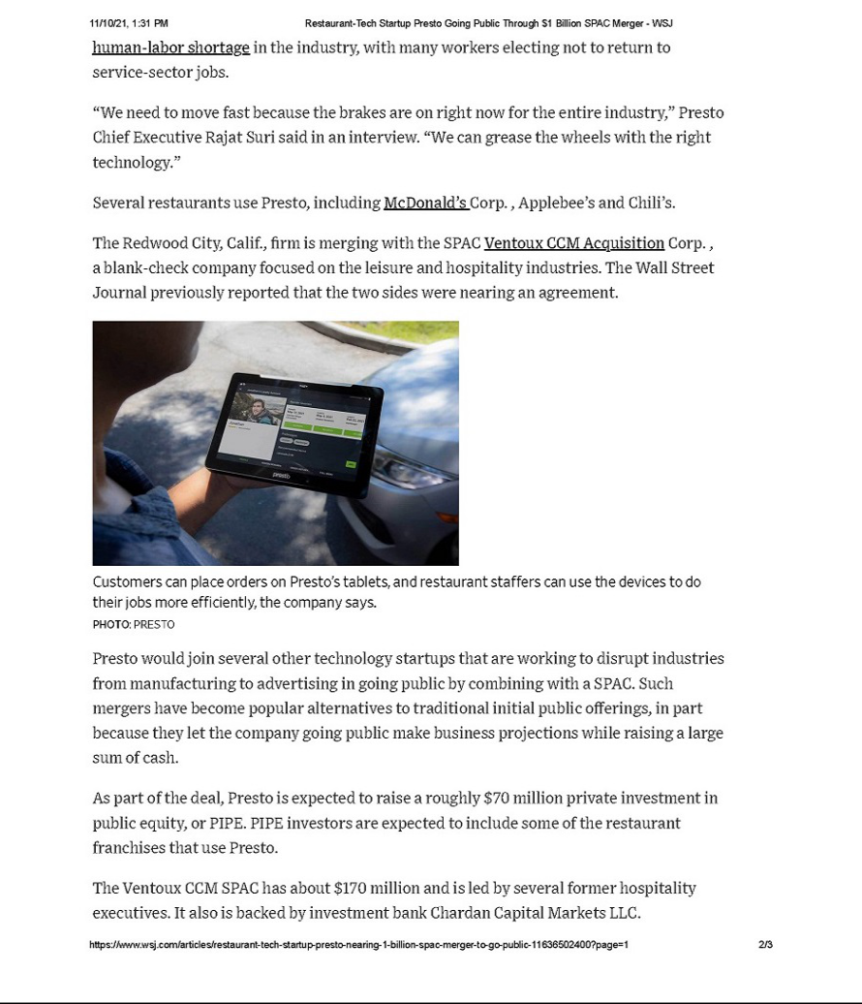

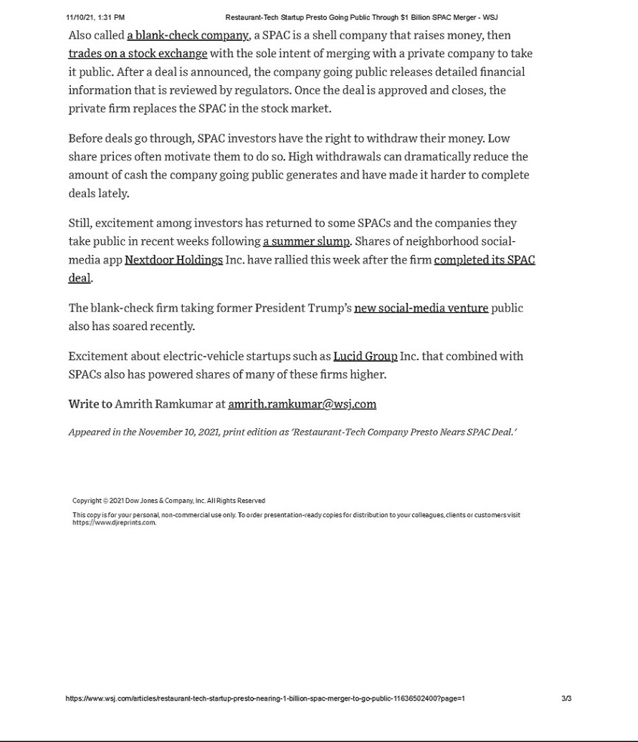

Additional Information and Where to Find It

In connection with the proposed business combination involving Ventoux and Presto, Ventoux intends to file a registration statement, which will include a preliminary proxy statement/prospectus, with the SEC. The proxy statement/prospectus will be sent to stockholders of Ventoux. This press release is not a substitute for the proxy statement/prospectus. INVESTORS AND SECURITY HOLDERS AND OTHER INTERESTED PARTIES ARE URGED TO READ THE PROXY STATEMENT/PROSPECTUS AND ANY OTHER RELEVANT DOCUMENTS THAT HAVE BEEN FILED OR WILL BE FILED WITH THE SEC, AS WELL AS ANY AMENDMENTS OR SUPPLEMENTS TO THESE DOCUMENTS, CAREFULLY AND IN THEIR ENTIRETY WHEN THEY BECOME AVAILABLE BECAUSE THEY WILL CONTAIN IMPORTANT INFORMATION ABOUT PRESTO, VENTOUX, THE PROPOSED BUSINESS COMBINATION AND RELATED MATTERS. The documents filed or that will be filed with the SEC relating to the proposed business combination (when they are available) can be obtained free of charge from the SEC’s website at www.sec.gov. These documents (when they are available) can also be obtained free of charge from Ventoux upon written request at Ventoux CCM Acquisition Corp., 1 East Putnam Avenue, Floor 4, Greenwich, CT 06830.

No Offer or Solicitation

This communication is for informational purposes only and is not intended to and shall not constitute a proxy statement or the solicitation of a proxy, consent or authorization with respect to any securities in respect of the proposed business combination and shall not constitute an offer to sell or the solicitation of an offer to buy or subscribe for any securities or a solicitation of any vote of approval, nor shall there be any sale, issuance or transfer of securities in any jurisdiction in which such offer, solicitation or sale would be unlawful prior to registration or qualification under the securities laws of any such jurisdiction.

Participants in Solicitation

This communication is not a solicitation of a proxy from any investor or security holder. However, Ventoux, Presto, and certain of their directors and executive officers may be deemed to be participants in the solicitation of proxies in connection with the proposed business combination under the rules of the SEC. Information about Ventoux’s directors and executive officers and their ownership of Ventoux’s securities is set forth in filings with the SEC, including Ventoux’s annual report on Form 10-K filed with the SEC on March 30, 2021 and amended on June 22, 2021. To the extent that holdings of Ventoux’s securities have changed since the amounts included in Ventoux’s most recent annual report, such changes have been or will be reflected on Statements of Change in Ownership on Form 4 filed with the SEC. Additional information regarding the participants will also be included in the proxy statement/prospectus, when it becomes available. When available, these documents can be obtained free of charge from the sources indicated above.

Forward-Looking Statements

This communication contains “forward-looking statements” within the meaning of the Private Securities Litigation Reform Act of 1995. Such statements include, but are not limited to, statements about future financial and operating results, our plans, objectives, expectations and intentions with respect to future operations, products and services; and other statements identified by words such as “will likely result,” “are expected to,” “will continue,” “is anticipated,” “estimated,” “believe,” “intend,” “plan,” “projection,” “outlook” or words of similar meaning. These forward-looking statements include, but are not limited to, statements regarding Presto’s industry and market sizes, future opportunities for Ventoux, Presto and the combined company, Ventoux’s and Presto’s estimated future results and the proposed business combination, including the implied pro forma equity value, the expected transaction and ownership structure and the likelihood and ability of the parties to successfully consummate the proposed business combination. Such forward-looking statements are based upon the current beliefs and expectations of our management and are inherently subject to significant business, economic and competitive uncertainties and contingencies, many of which are difficult to predict and generally beyond our control. Actual results and the timing of events may differ materially from the results anticipated in these forward-looking statements.

In addition to factors previously disclosed or that will be disclosed in Ventoux’s reports filed with the SEC and those identified elsewhere in this communication, the following factors, among others, could cause actual results and the timing of events to differ materially from the anticipated results or other expectations expressed in the forward-looking statements: (1) the occurrence of any event, change or other circumstances that could give rise to the termination of the merger agreement or could otherwise cause the transactions contemplated therein to fail to close; (2) the outcome of any legal proceedings that may be instituted against Ventoux, Presto, the Company or others following the announcement of the proposed business combination and any definitive agreements with respect thereto; (3) the inability to complete the proposed business combination due to the failure to obtain approval of the stockholders of Ventoux or Presto; (4) the inability of Presto to satisfy other conditions to closing; (5) changes to the proposed structure of the proposed business combination that may be required or appropriate as a result of applicable laws or regulations or as a condition to obtaining regulatory approval of the proposed business combination; (6) the ability to meet stock exchange listing standards in connection with and following the consummation of the proposed business combination; (7) the risk that the proposed business combination disrupts current plans and operations of Presto as a result of the announcement and consummation of the proposed business combination; (8) the ability to recognize the anticipated benefits of the proposed business combination, which may be affected by, among other things, competition, the ability of the Company to grow and manage growth profitably, grow its customer base, maintain relationships with customers and suppliers and retain its management and key employees; (9) the impact of the COVID-19 pandemic on the business of Presto and the Company (including the effects of the ongoing global supply chain shortage); (10) Presto’s limited operating history and history of net losses; (11) Presto’s customer concentration and reliance on a limited number of key technology providers and payment processors facilitating payments to and by Presto’s customers; (12) costs related to proposed business combination; (13) changes in applicable laws or regulations; (14) the possibility that Presto or the Company may be adversely affected by other economic, business, regulatory, and/or competitive factors;

- Presto’s estimates of expenses and profitability; (16) the evolution of the markets in which Presto competes; (17) the ability of Presto to implement its strategic initiatives and continue to innovate its existing products; (18) the ability of Presto to adhere to legal requirements with respect to the protection of personal data and privacy laws; (19) cybersecurity risks, data loss and other breaches of Presto’s network security and the disclosure of personal information; and (20) the risk of regulatory lawsuits or proceedings relating to Presto’s products or services.

Actual results, performance or achievements may differ materially, and potentially adversely, from any projections and forward-looking statements and the assumptions on which those forward-looking statements are based. There can be no assurance that the data contained herein is reflective of future performance to any degree. You are cautioned not to place undue reliance on forward-looking statements as a predictor of future performance as projected financial information and other information are based on estimates and assumptions that are inherently subject to various significant risks, uncertainties and other factors, many of which are beyond our control. All information set forth herein speaks only as of the date hereof in the case of information about Ventoux and Presto or the date of such information in the case of information from persons other than Ventoux and Presto, and we disclaim any intention or obligation to update any forward-looking statements as a result of developments occurring after the date of this communication. Forecasts and estimates regarding Presto’s industry and end markets are based on sources we believe to be reliable, however there can be no assurance these forecasts and estimates will prove accurate in whole or in part. Annualized, pro forma, projected and estimated numbers are used for illustrative purpose only, are not forecasts and may not reflect actual results.

